**Project Planning Phase**

**Project Planning Template (Product Backlog, Sprint Planning, Stories, Story points)**

| **Date** | **04th November 2023** |
| --- | --- |
| **Team ID** | **Team - 591979** |
| **Project Name** | **ASL - Alphabet Image Recognition** |
| **Maximum Marks** | **8 Marks** |
| **Team members** | **Pujyam Sathvika, Rishika Krishna Ch** |

**Product Backlog, Sprint Schedule, and Estimation (4 Marks)**

| **Sprint** | **Functional**  **Requirement**  **(Epic)** | **User Story Number** | **User Story / Task** | **Story points** | **Priority** | **Team Members** |
| --- | --- | --- | --- | --- | --- | --- |
| Sprint-1 | Projet setup and infrastructure | USN-1 | Set up the development environment with the required tools and frameworks to start the ASL project . | 1 | High | Rishika, Sathvika |
| Sprint-1 | Data collection | USN-2 | Gather a diverse and large dataset of images containing all the different classes of alphabets(A, B, C, D, ….., Z), space, nothing, delete. | 2 | High | Rishika, Sathvika |
| Sprint-2 | Data Preprocessing | USN-3 | Preprocess the collected images by resizing and normalizing. Split the data into training and testing sets. | 3 | High | Sathvika |
| Sprint-2 | Model Development | USN - 4 | Explore different deep learning architectures to select the most suitable one(CNN) for our ASL project. | 4 | High | Rishika |
| Sprint - 2 | Training | USN-5 | As a customer, I want a well trained model and very accurate predictions for the images I upload. Task: Implement data augmentation techniques to improve model’s accuracy. | 4 | Medium | Sathvika, Rishika |
| Sprint - 3 | Integrate the ASL recognition system into applications and services. | USN - 6 | As a developer, I want the ASL recognition system to offer an API or web browser for easy accessibility. | 6 | Medium | Sathvika, Rishika |
| Sprint - 3 | Develop a web-based user interface for the ASL recognition system that provides users with a simple way to interact with the system. | USN - 7 | As a customer, I want to access the ASL recognition system through a user-friendly web interface, so I can easily interact with the system without the need to install additional software | 6 | High | Sathvika, Rishika |

**Project Tracker:**

| **Sprint** | **Total Story**  **Points** | **Duration** | **Sprint Start Date** | **Sprint End Date**  **(Planned)** | **Story Points**  **Completed (as on Planned End Date)** | **Sprint Release Date**  **(Actual)** |
| --- | --- | --- | --- | --- | --- | --- |
| Sprint-1 | 3 | 3 Days | 25 Oct 2023 | 27 Oct 2023 | 3 | 27 Oct 2022 |
| Sprint-2 | 11 | 5 Days | 28 Oct 2023 | 01 Nov 2023 | 11 | 01 Nov 2023 |
| Sprint-3 | 12 | 5 Days | 02 Nov 2023 | 06 Nov 2023 |  |  |

**Velocity:**

Average velocity = Total number of points / Total number of days = 26 / 13 = 2

Average sprint velocity = Total number of points / Total number of sprints = 26 / 3 = 9 (approx)

**Velocity Report:**

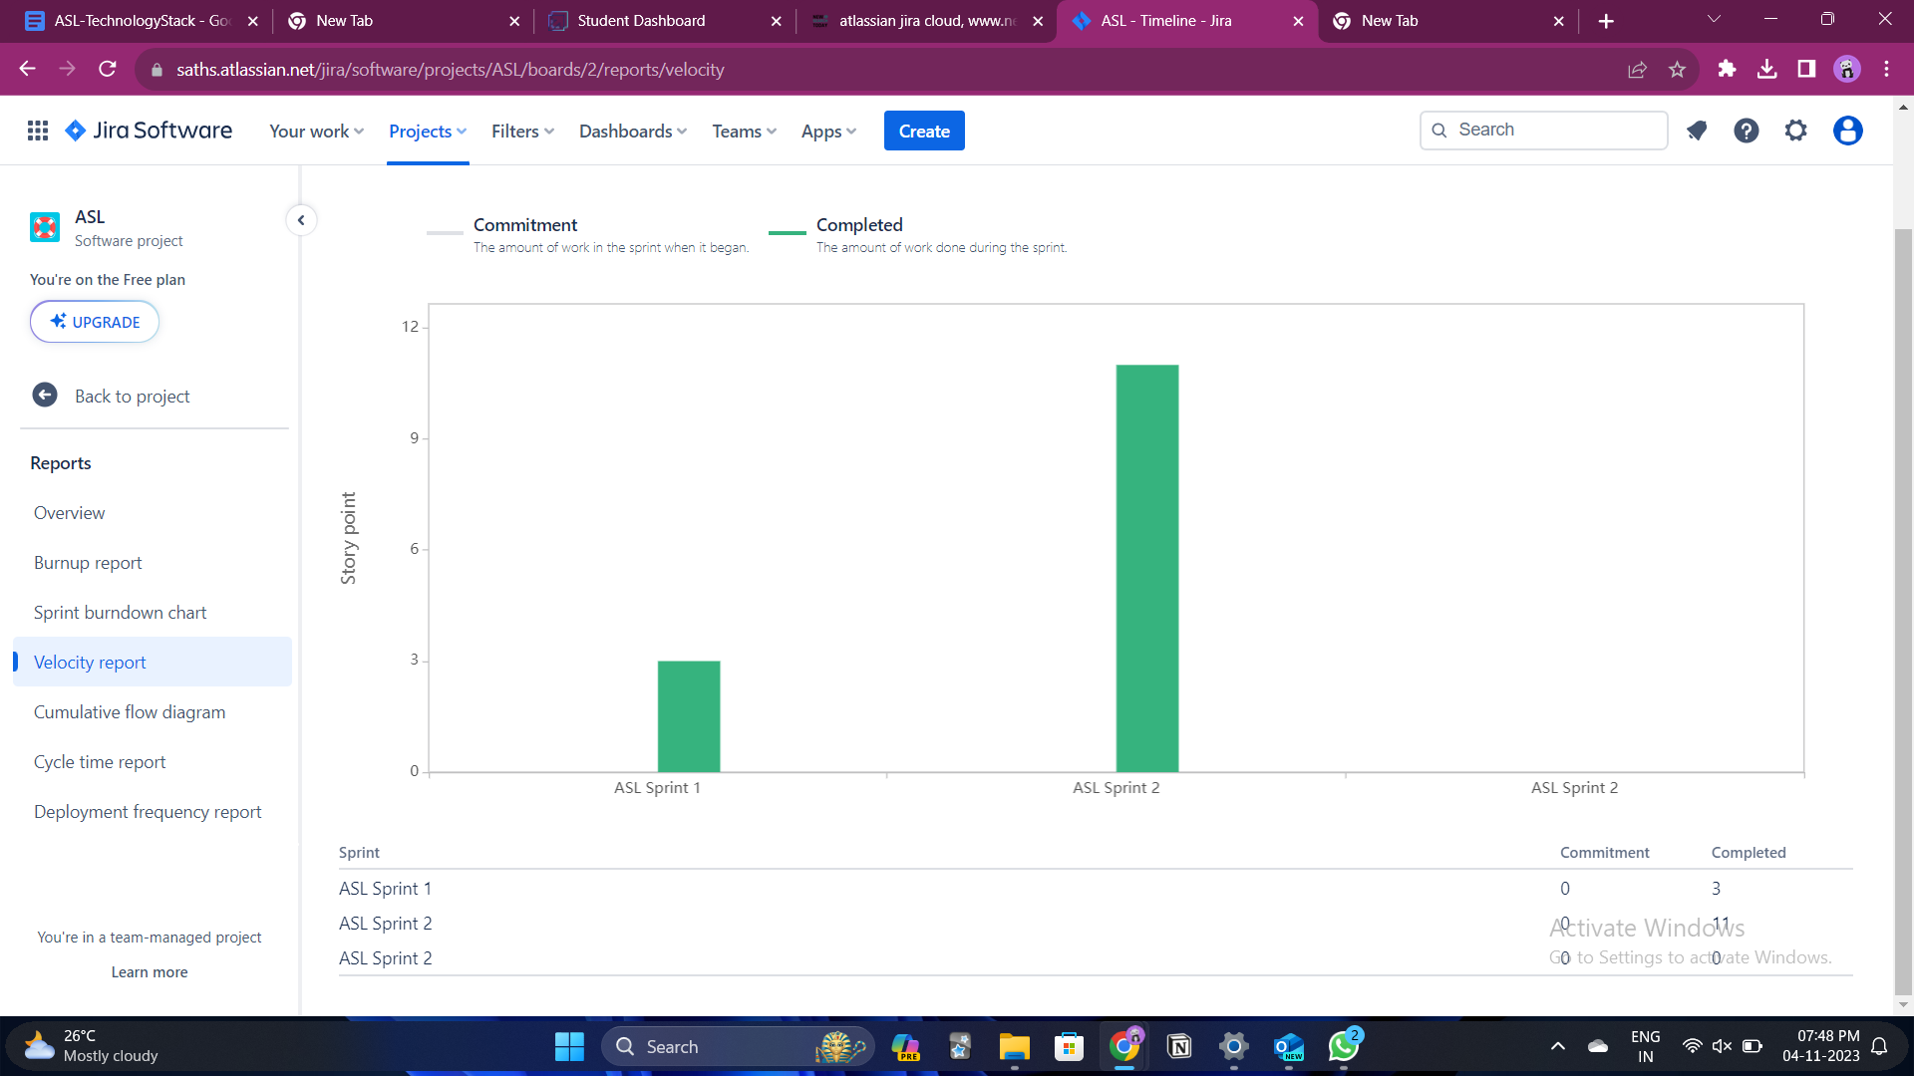

**Burndown Chart:**

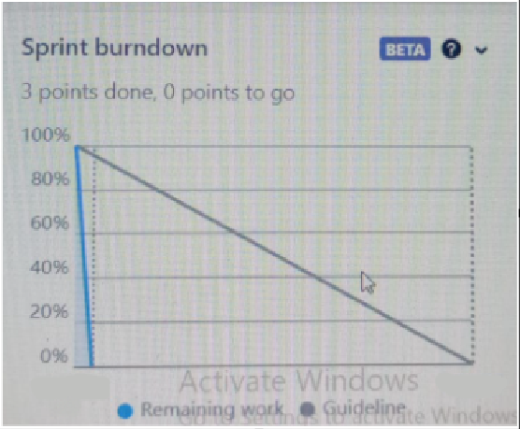

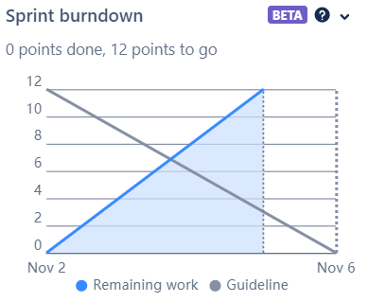

**Timeline section:**

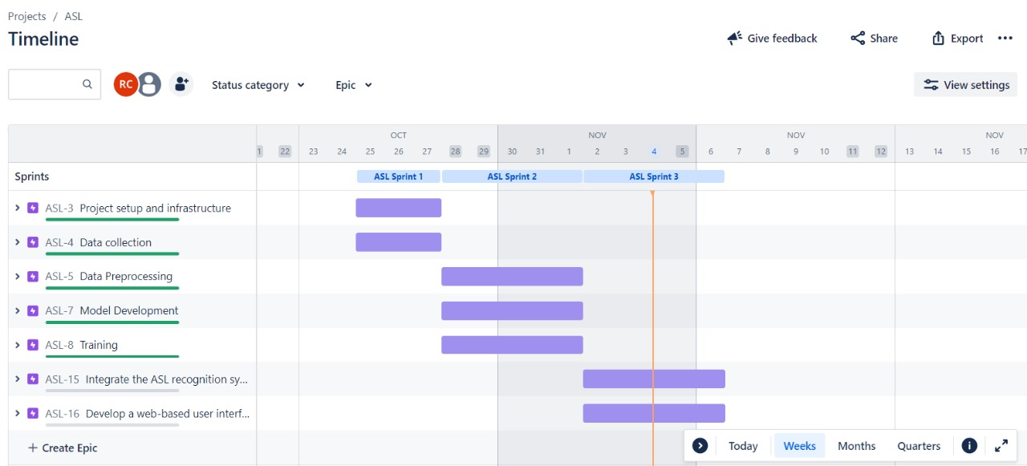

**Backlog section:**

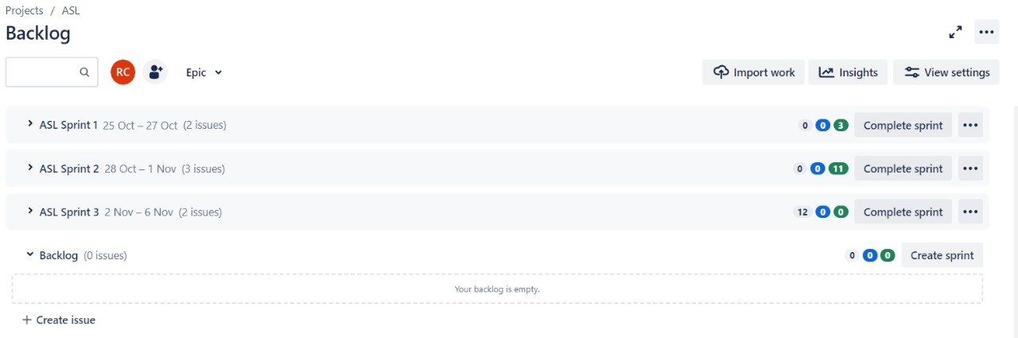

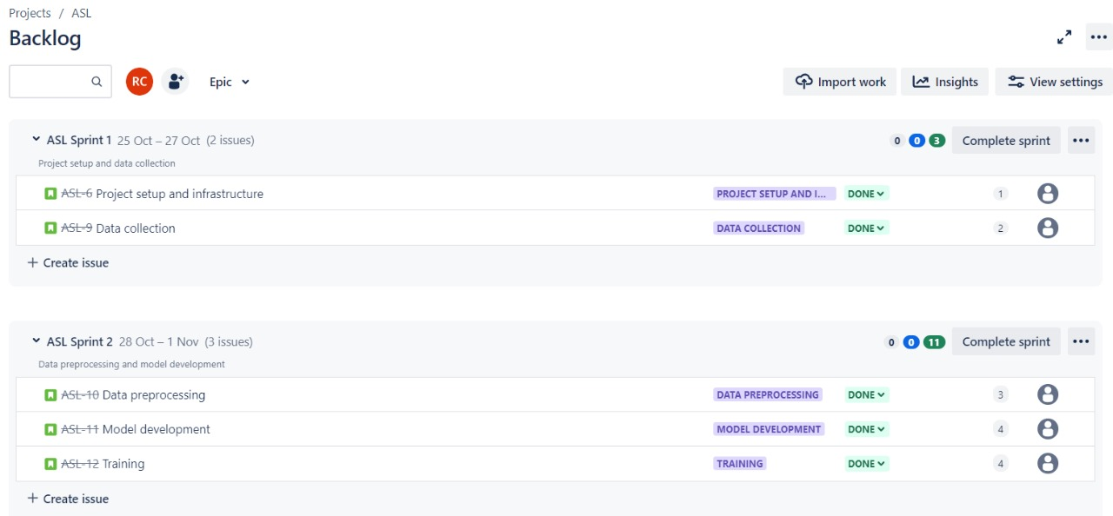

**Board section:**

